附件3
山西省第九届高等职业院校英语口语技能大赛样题
Part I Reading Aloud （2 minutes）
You are required to read aloud the following short speech.
OK everyone, just a few words about Bill’s retirement. When I told people I was going to make a retirement speech today, they got quite excited…. until I explained that it wasn't me who was retiring.
Bill, you were here long before I joined the organization. In fact, I reckon you know more stories than anyone else about what's happened here over the years. Remember that time when a horse got into the warehouse a few years back? You were the only one who was brave enough to go in and get it out. What amazed everyone though was when you came out riding on its back!
Anyway Bill, we would all like to wish you the best of fortune for the future. If we get any problems again with livestock ‘horses’ we'll call you; but other than that, have a great time with the fishing.
Many thanks for all you've done for us Bill, and best of luck for a long and happy retirement.

Part II Presentation (3 minutes)
You are required to give your account and comment of the intention of different age
groups for being a manager based on the following illustration.

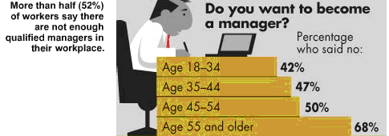
Part III Interview (3 minutes)
Now you’ll see a list of shows at GTC Cinema.
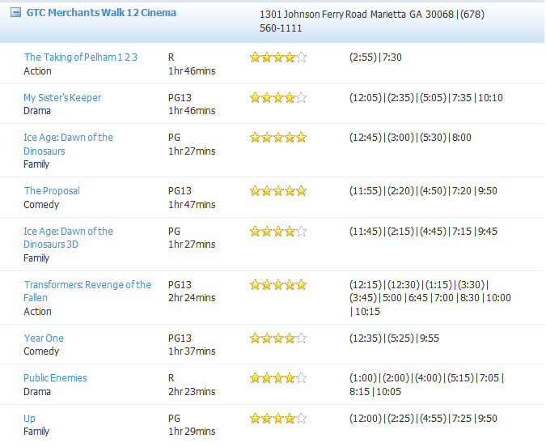
* PG = parental guidance
PG13 = a warning to parents to determine whether their children under age 13 should view the motion picture
R = motion pictures not appropriate for parents to bring their young children with them
Suppose you’re a ticket-office clerk now helping a customer choose a show. You will answer questions from the customer.
Contestant: A ticket-office clerk
Question Master: A customer
No. of Questions: 8-10

